PROJECT DOCUMENTATION

Prepared by: ASHMITHAA P
Course: Data Analytics and Data Science
Batch: August – 2025

DATA ANALYTICS MILESTONE PROJECT REPORT

PROJECT TITLE:
Global Economic and Demographic Trends Analysis

ABSTRACT
This milestone report outlines the progress of the Global Economic and Demographic Trends Analysis project. The project leverages Power BI to analyze large-scale global datasets related to population, economic growth, health, and literacy indicators spanning the years 1960 to 2017. Data collected from SQL databases and Excel sources is systematically integrated, cleaned, and transformed using Power Query to ensure accuracy and consistency. Through the application of DAX calculations and interactive visualizations, the project uncovers meaningful patterns and relationships across countries and regions. The developed dashboards enable comparative analysis, trend identification, and data-driven exploration, providing valuable insights into global development dynamics and socio-economic disparities.

1.INTRODUCTION
The increasing availability of global demographic and economic data has enabled organizations and researchers to perform data-driven analysis of long-term development trends. However, raw data collected from multiple sources is often complex, unstructured, and difficult to interpret without proper analytical tools. This project focuses on transforming multi-source global datasets into structured, meaningful insights using Power BI. By integrating demographic, economic, health, and literacy data, the project provides interactive dashboards that support trend analysis, cross-country comparisons, and regional benchmarking, thereby facilitating informed decision-making and strategic evaluation of global development patterns.

2. PROBLEM STATEMENT
• Global demographic and economic data is scattered across multiple sources and formats, making consolidation and analysis challenging.
• Manual data analysis methods are time-consuming, inefficient, and prone to errors when handling large historical datasets.
• Identifying meaningful patterns, trends, and disparities at regional and country levels is difficult without proper data modeling and analytical tools.
• The absence of interactive and dynamic visualizations limits effective exploration of data and reduces the ability to support data-driven decision-making.

3. OBJECTIVES
• Analyze global and regional population growth patterns and GDP trends over time to understand economic and demographic changes.
• Examine key health and literacy indicators, such as infant mortality rates and literacy levels, and assess their relationship with economic performance.
• Design and develop interactive Power BI dashboards using appropriate visualizations, KPIs, and slicers to enhance data exploration.
• Enable comparative global analysis across countries and regions to identify disparities, trends, and development patterns that support data-driven insights and decision-making.

4.DATASET DESCRIPTION
The dataset used in this project consists of global indicators related to population, GDP, GDP per capita, infant mortality rates, and literacy levels. The data is collected from multiple sources, including SQL databases and Microsoft Excel files, and covers historical records across several decades. These datasets provide country- and region-level information, enabling detailed comparative and trend analysis. Prior to analysis, the data is integrated and prepared to ensure consistency, accuracy, and suitability for visualization and reporting in Power BI.

5. METHODOLOGY
• Data Import
Data is imported into Power BI using built-in connectors to integrate datasets from SQL databases and Microsoft Excel files.
• Data Cleaning and Transformation
Power Query is used to clean and preprocess the data by handling missing values, correcting data types, standardizing country and region names, and ensuring overall data consistency.
• Data Modeling and Relationships
Relationships between tables are created using common keys such as country name, country code, and year to support accurate aggregation and cross-filtering across visuals.
• DAX Calculations
Data Analysis Expressions (DAX) are implemented to create calculated measures and metrics, including GDP per capita, population growth rates, averages, and rankings.
•DashboardDevelopment
Interactive dashboards are developed using appropriate visualizations, KPI cards, slicers, and filters to enable dynamic exploration and comparative analysis of global trends.

6. TOOLS AND TECHNOLOGIES
Power BI – Used for data integration, data modeling, DAX calculations
SQL – Utilized for storing, managing, and querying structured economic and demographic data
Microsoft Excel – Used as a data source for importing supplementary datasets and reference tables.
DAX (Data Analysis Expressions) – Applied to create calculated measures, aggregations, and KPIs

7.DATA INTEGRATION
The data integration phase of this project involves connecting and consolidating multiple data sources to create a unified analytical dataset for global economic and demographic analysis. Data is sourced from both a SQL database and Microsoft Excel files, containing historical records spanning the years 1960 to 2017. These datasets include information on population, GDP, GDP per capita, infant mortality rates, literacy levels, and country-specific attributes.
Power BI is used to establish direct connections to the SQL database, enabling efficient retrieval of structured economic and demographic data. At the same time, Excel files are imported to supplement the analysis with additional indicators and reference tables. During the integration process, Power Query is utilized to clean, transform, and standardize the data. This includes handling missing values, aligning country and region naming conventions, correcting data types, and ensuring consistency across different time periods.
Multiple datasets are then merged using common keys such as Country, Region, and Year, forming a consolidated data model suitable for analysis. Relationships are carefully defined within Power BI to enable accurate cross-filtering and aggregation across visuals. By integrating data from multiple sources into a single Power BI model, the project ensures a comprehensive and reliable foundation for analyzing long-term global trends and deriving meaningful insights from complex, multi-dimensional data.

8.ANALYSIS & INSIGHTS
The analysis phase of this project applies descriptive statistical techniques to examine global trends in population, economic performance, health indicators, and literacy levels. Using DAX in Power BI, key measures and calculated fields are developed to summarize, compare, and interpret large volumes of historical data spanning multiple decades.
Descriptive statistics—including totals, averages, growth rates, maximums, and minimums—are calculated to analyze population distribution, population density, and demographic changes across countries and regions. Economic indicators such as GDP and GDP per capita are evaluated to identify development patterns and economic disparities, while year-over-year calculations reveal long-term economic growth trends.
A variety of visual analytics—such as time-series charts, scatter plots, trend lines, and KPI cards—are used to uncover correlations, highlight patterns, and emphasize key performance metrics, including highest growth rates and lowest mortality levels. Through these DAX-driven descriptive analyses, the project delivers clear, data-backed insights into the interconnected dynamics of population growth, economic development.

9.VISUALIZATION
The visualization component of this project focuses on designing an interactive and intuitive Power BI dashboard that effectively communicates global patterns and relationships across population, economic, health, and literacy indicators. A variety of carefully selected visualizations are used to represent different types of data, ensuring clarity, accuracy, and ease of interpretation for users.
Bar and column charts are employed to compare population size, population density, GDP per capita, and literacy rates across regions and countries. Line charts are used to illustrate trends over time, such as changes in infant mortality rates, population growth, and GDP growth. Geographical insights are presented using maps to visualize population density by country. KPI cards summarize critical metrics like highest and lowest GDP per capita, fastest population growth, and lowest infant mortality rates. Slicers are integrated across the dashboard, allowing users to dynamically explore data by country, region, and time period.

10.DATA SOURCES
This project utilizes four key data sources to analyze global population, economic performance, health indicators, and country-level characteristics. These datasets span the period from 1960 to 2017 and are integrated to provide a comprehensive and consistent foundation for analysis.
10.1Population Per Country Data
This dataset contains country- and region-wise population statistics over multiple years. It includes total population counts and related attributes, which are used to analyze population distribution, density across different regions.
10.2. GDP by Years Data
The economic dataset provides information on GDP and GDP per capita for countries, population etc. This data enables comparision of economic growth .
10.3. Countries of the world Data
This dataset includes literacy rates and other country-level attributes such as region classification and income group. It supports the analysis of how education levels and economic performance.

11. STATISTICAL ANALYSIS
11.1Population Analysis
As part of the analysis, statistical measures such as mean, median, mode, and standard deviation are derived to summarize population data effectively.
11.2 GDP Metrics
The GDP metrics analysis focuses on evaluating GDP per capita as a key indicator of economic performance in countries and regions. The average GDP per capita is calculated at both the country and regional levels.
11.3Infant Mortality Analysis
The infant mortality analysis examines the distribution of infant mortality rates across countries and regions to assess global health conditions. Using statistical techniques and DAX calculations infant mortality rates are summarized to understand their overall spread and variation.
11.4 Literacy Rates Analysis
The literacy rate analysis is used for evaluating average literacy levels across different regions to understand educational development and regional disparities. Using DAX calculations literacy data is aggregated at the regional level to compute average literacy rates, providing a summarized view of educational growth across countries and regions.
11.5 Growth Trend Analysis
The growth trends analysis examines key indicators such as population, GDP, GDP per capita, infant mortality, and literacy rates for the period 1960–2017, by using analysis trends are visualized to identify patterns of growth or decline in growth across countries and regions.

12. DAX FUNCTIONS
To derive broader insights from the integrated global datasets, DAX functions are applied in Power BI. These functions allow for the creation of calculated measures, columns, and aggregations that are not directly available in the raw data, enabling sophisticated analysis across population, economic, health, and educational indicators.
Examples of DAX functions used in this project include:
- CALCULATE – Modifies the context of calculations to compute region-specific or year-specific aggregates, such as total population or average GDP per capita for a selected region.
- FILTER – Applies dynamic filters to measures, for instance, calculating infant mortality only for countries with populations above a certain threshold.
- RANKS – Ranks countries or regions based on selected metrics, such as identifying countries with the highest or lowest literacy rates or GDP per capita.

DAX FORMULA:
Total GDP = SUM('GDP’ [GDP])
Max GDP = MAX('GDP’ [GDP])
Min GDP = MIN('GDP’ [GDP])
MeanPopulation = AVERAGE(PopulationPerCountry[Population])
MedianPopulation = MEDIAN(PopulationPerCountry[Population])
STD Population = STDEV.P(PopulationPerCountry[Population])
Total Population = SUM(PopulationPerCountry[Population])
Avg GDP per Capita = AVERAGE('GDP [GDP])
Country with Highest GDP =
VAR maxGDP = MAX('GDP by years 1960-2016'[GDP])
RETURN
CALCULATE(SELECTEDVALUE('GDP’ [Country Name]),
'GDP’ [GDP] = maxGDP)
Country with Lowest GDP =
VAR minGDP = MIN('GDP’[GDP])
RETURN
CALCULATE(SELECTEDVALUE('GDP’[CountryName]),'GDP’ [GDP]=minGDP)

DASHBOARD
POWER BI DASHBOARD
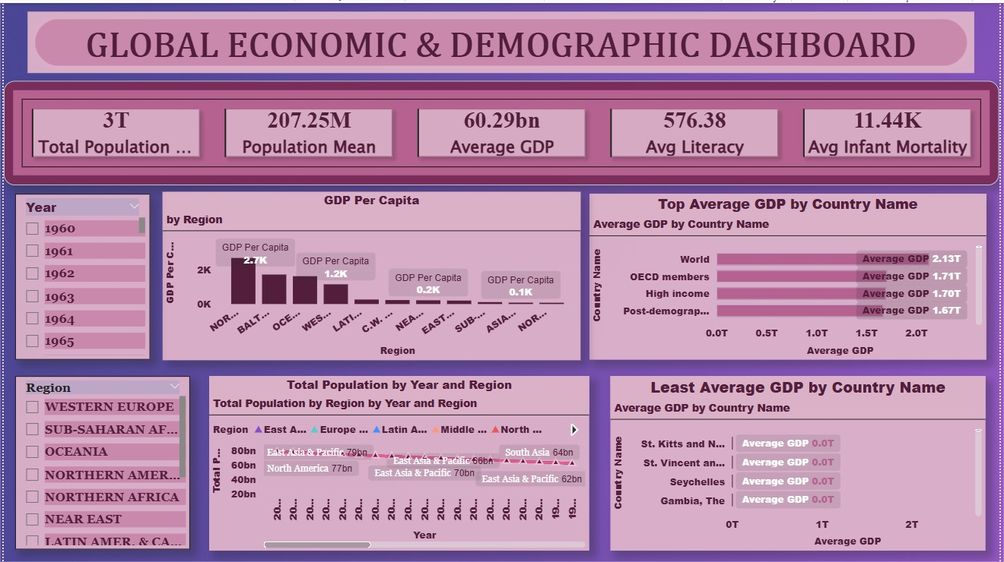

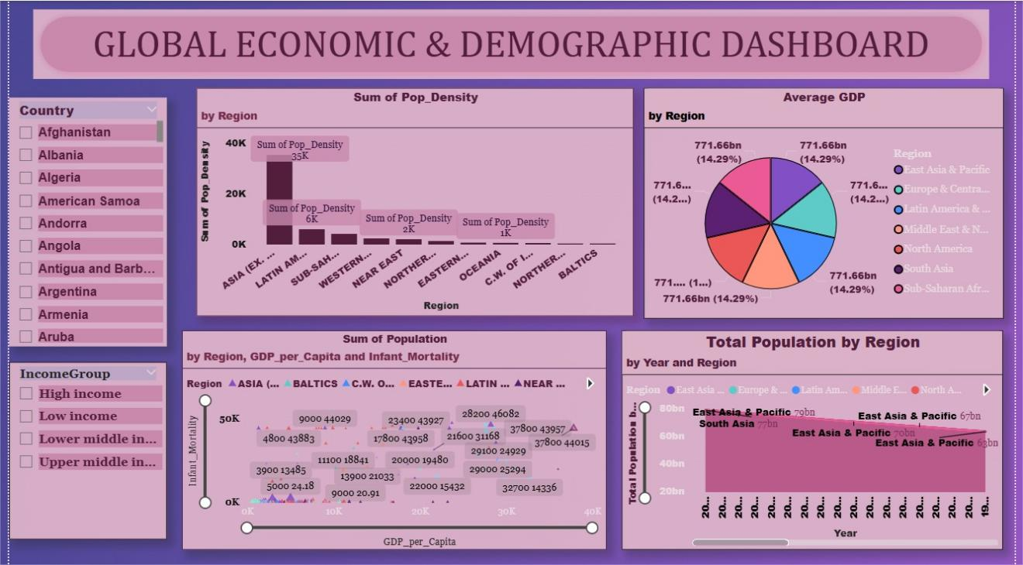

CONCLUSION
The dashboard provides a comprehensive and interactive view of global economic trends from 1960 to 2017, highlighting the strong interconnectedness between population dynamics, economic developments, Through visual exploration, users can easily identify global inequalities, regional disparities, and long-term development patterns, enabling a clear and data-driven understanding of world wide economic trends.

